

University of Mazandaran

Faculty of (type the name of the faculty here)

A thesis

Submitted in Partial fulfillment of the requirements for the degree of

Master of Science / Arts in (type the name of the major here)

Title:

(Type the thesis title here).

Author:

(Type the name of the researcher/student here)

Supervisor:

(Type the name of the supervisor/supervisors here)

Advisor:

(Type the name of the advisor/advisors here)

(Type the date of the final oral defense here)



**Certificate of Originality of the Thesis**

I (type the author's name here), a postgraduate student in the field of (type the field of study here) with the student number of (type the student ID here), certify that all the contents of this thesis titled (type the title here) are the result of my own research work, prepared under the supervision and advice of the professors in University of Mazandaran. Moreover, wherever the achievements or scientific works of others have been used, they have been referred to directly or indirectly within the in-text citation of the thesis and in the references. This thesis has not been previously submitted for obtaining any degree of the same, higher or lower degree from any governmental or non-governmental Universities and Institutes. If any violation is proved in my thesis, the University of Mazandaran will have the right to pursue the matter judicially and I will have no objection.

All the findings and rights of this work belong to the University of Mazandaran; any use of the scientific and practical findings, transfer of information to others or printing and duplication, as well as copying and adapting translations of the thesis are prohibited without the consent of the University of Mazandaran or the supervisor/advisor. Quoting the content is allowed only in the case of mentioning the source.

The authenticity of the student's signature is certified.

**Student's name and signature**

**Dean of Faculty**

**Vice Chancellor for Research**

**Final Oral Defense Report**

Faculty of ….

Table 1. Student’s information

|  |  |  |  |  |  |
| --- | --- | --- | --- | --- | --- |
| First Name and Last Name | Major | Field | Program type (state funded/tuition-based) | Entrance Year | Student ID |
|  |  |  |  |  |  |
| Email Address: | | | | | |

Table 2. Thesis title and final oral defense date

|  |  |
| --- | --- |
| Thesis Title |  |
| Final Oral Defense Date and Time |  |

Table 3. Evaluation score

|  |  |  |  |  |
| --- | --- | --- | --- | --- |
| Score (in number) | | Score (in word): | | |
| Less than 14 | 14-15.99 | 16-17.99 | 18-18.99 | 19-20 |
| Failed | Acceptable | Good | Very Good | Excellent |

Table 4. Professor’s information

|  |  |  |  |  |  |
| --- | --- | --- | --- | --- | --- |
| First Name and Last Name | Specialty and Research Domain | Academic Rank | Position in Thesis | Affiliation | Date and Signature |
|  |  |  |  |  |  |
|  |  |  |  |  |  |
|  |  |  |  |  |  |
|  |  |  |  |  |  |
|  |  |  |  |  |  |
|  |  |  |  |  |  |

Table 5. Postgraduate representative’s information

|  |  |
| --- | --- |
| First Name and Last Name | Date and Signature |
|  |  |

**Acknowledgement**

**Dedication**

**Abstract**

Type your Persian text in B Nazanin 13 font and your English text in Times new roman 11. Then, in the “Styles” window, click on “Text Styles” to adjust the text.

**Keywords:** (keyword one), (keyword two), (keyword three), (keyword four), (keyword five)

**Contents**

Title Page

Chapter 1: [Type the chapter title here] 14

1.1. Heading 1 (After typing the title, click on Title 1 in the "Styles" window)…………………………………………………………...…..15

1.2. Heading 1 (After typing the title, click on Title 1 in the "Styles" window)…………………………………………………………...…..15

1.3. Heading 1 (After typing the title, click on Title 1 in the "Styles" window)………………………………………………………..….…..15

1.4. Heading 1 (After typing the title, click on Title 1 in the "Styles" window)…………………………………………………………..…...15

1.5. Heading 1 (After typing the title, click on Title 1 in the "Styles" window)…………………………………………………………..…...16

1.6. Heading 1 (After typing the title, click on Title 1 in the "Styles" window)…………………………………………………………….....16

1.6.1. Heading 2 (After typing the title, click on Title 2 in the "Styles" window)…..…………………………………………….……16

1.6.2. Heading 2 (After typing the title, click on Title 2 in the "Styles" window)………………………….. …………………………16

1.6.3. Heading 2 (After typing the title, click on Title 2 in the "Styles" window)………………………………………….. …………17

**Chapter 2: [Type the chapter title here]** 18

2.1. Heading 1 (After typing the title, click on Title 1 in the “Styles” window)…….………………………………………………………....19

2.2. Heading 1 (After typing the title, click on Title 1 in the “Styles” window)…………………………………………………………...…..19

2.2.1. Heading 2 (After typing the title, click on Title 2 in the “Styles” window)…… ……………………………...…………..……19

2.2.1.1. Heading 3 (After typing the title, click on Title 2 in the “Styles” window)……..….……..........….…………………..20

2.2.1.2. Heading 3 (After typing the title, click on Title 2 in the “Styles” window)…………... ………………………..……..21

2.2.1.3. Heading 3 (After typing the title, click on Title 2 in the “Styles” window)……………….…………………………..22

**Chapter 3: [Type the chapter title here]** 23

3.1. Heading 1 (After typing the title, click on Title 1 in the “Styles” window)…………………………………………………………...…..24

3.1.1. Heading 2 (After typing the title, click on Title 2 in the “Styles” window)………….. ………………………….……………24

**Chapter 4: [Type the chapter title here]** 26

4.1. Heading 1 (After typing the title, click on Title 1 in the Style window)…………………………………………………………...…..27

4.1.1. Heading 2 (After typing the title, click on Title 2 in the “Styles” window)…………... ……………………………………..……27

4.1.1.1. Heading 3 (After typing the title, click on Title 2 in the “Styles” window)………..…………………………………..28

4.1.1.1.1. Heading 4 (After typing the title, click on Title 4 in the “Styles” window)………………………… ……………..29

**Chapter 5: [Type the chapter title here]** 30

5.1. Heading 1 (After typing the title, click on Title 1 in the “Styles” window)…………………………………………………………...…..31

5.1.1. Heading 2 (After typing the title, click on Title 2 in the “Styles” window)…………...…………………………...………………31

5.1.1.1. Heading 3 (After typing the title, click on Title 2 in the “Styles” window)…….……………………………………..32

5.1.1.1.1. Heading 4 (After typing the title, click on Title 4 in the “Styles” window)… ……………………..…...…………..33

References…………….…………………………………………………34

Appendices……………….……………………………………………...35

Descriptive Words………………………………….……………….36

Persian-English Words……………………….……………………..37

English-Persian Words………………….…………………………..38

Reviewers’ Approval/Final Oral Defense Report……………………….39

**After writing the thesis and clicking on the “Styles”, right-click on the list and select “Update Field”. Then select “Update Entire Table” and update the list.**

**List of Tables**

Title Page

Table 2.1. Type the table title here (After typing, click on the “Table Styles” to format it 21

Table 2.2. Type the table title here (After typing, click on the “Table Styles” to format it 22

Table 4.1. Type the table title here (After typing, click on the “Table Styles” to format it 27

Table 5.1. Type the table title here (After typing, click on the “Table Styles” to format it 31

**After writing the thesis and clicking on the “Styles”, right-click on the list and select “Update Field”. Then select “Update Entire Table” and update the list.**

**List of Figures**

Title Page

Figure 2.1. Type the figure title here (After typing, click on the “Figure Styles” to format it 19

Figure 2.2. Type the figure title here (After typing, click on the “Figure Styles” to format it 20

Figure 3.1. Type the figure title here (After typing, click on the “Figure Styles” to format it 24

Figure 4.1. Identification of the main components of the symmetry index using PCA method 28

Figure 4.2. Identification of the main components of the symmetry index using PCA method 29

Figure 5.1. Identification of the main components of the symmetry index using PCA method 32

Figure 5.2. Identification of the main components of the symmetry index using PCA method 33

**After writing the thesis and clicking on the “Styles”, right-click on the list and select “Update Field”. Then select “Update Entire Figure” and update the list.**

**List of Charts**

Title Page

Chart 4.1. Type the chart title here (After typing, click on the “Chart Styles” to format it 25

Chart 4.2. Type the chart title here (After typing, click on the “Chart Styles” to format it 28

Chart 5.1. Type the chart title here (After typing, click on the “Chart Styles” to format it 32

**After writing the thesis and clicking on the “Styles”, right-click on the list and select “Update Field”. Then select “Update Entire Chart” and update the list.**

**List of Abbreviations**

|  |  |
| --- | --- |
| Abbreviation | Full Name |
| Abbreviation | Full Name |
| Abbreviation | Full Name |
| Abbreviation | Full Name |

Chapter 1:   
[Type the chapter title here]

(After typing the title, click on the “Chapters” in the “Styles” window.

* 1. Heading 1 (After typing the title, click on “Title 1” in the “Styles” window)

Type your Persian text in B Nazanin 13 font and your English text in Times new roman 11. Then, in the “Styles” window, click on “Text Styles” to adjust the text.

* 1. Heading 1 (After typing the title, click on “Title 1” in the “Styles” window)

Type your Persian text in B Nazanin 13 font and your English text in Times new roman 11. Then, in the “Styles” window, click on “Text Styles” to adjust the text.

* 1. Heading 1 (After typing the title, click on “Title 1” in the “Styles” window)

Type your Persian text in B Nazanin 13 font and your English text in Times new roman 11. Then, in the “Styles” window, click on “Text Styles” to adjust the text.

* 1. Heading 1 (After typing the title, click on “Title 1” in the “Styles” window)

Type your Persian text in B Nazanin 13 font and your English text in Times new roman 11. Then, in the “Styles” window, click on “Text Styles” to adjust the text.

Type your Persian text in B Nazanin 13 font and your English text in Times new roman 11. Then, in the “Styles” window, click on “Text Styles” to adjust the text.

* 1. Heading 1 (After typing the title, click on “Title 1” in the “Styles” window)

Type your Persian text in B Nazanin 13 font and your English text in Times new roman 11. Then, in the “Styles” window, click on “Text Styles” to adjust the text.

Type your Persian text in B Nazanin 13 font and your English text in Times new roman 11. Then, in the “Styles” window, click on “Text Styles” to adjust the text.

* 1. Heading 1 (After typing the title, click on “Title 1” in the “Styles” window)
     1. Heading 2 (After typing the title, click on “Title 2” in the “Styles” window)

Type your Persian text in B Nazanin 13 font and your English text in Times new roman 11. Then, in the “Styles” window, click on “Text Styles” to adjust the text.

Type your Persian text in B Nazanin 13 font and your English text in Times new roman 11. Then, in the “Styles” window, click on “Text Styles” to adjust the text.

* + 1. Heading 2 (After typing the title, click on “Title 2” in the “Styles” window)

Type your Persian text in B Nazanin 13 font and your English text in Times new roman 11. Then, in the “Styles” window, click on “Text Styles” to adjust the text.

Type your Persian text in B Nazanin 13 font and your English text in Times new roman 11. Then, in the “Styles” window, click on “Text Styles” to adjust the text.

* + 1. Heading 2 (After typing the title, click on “Title 2” in the “Styles” window)

Type your Persian text in B Nazanin 13 font and your English text in Times new roman 11. Then, in the “Styles” window, click on “Text Styles” to adjust the text.

Type your Persian text in B Nazanin 13 font and your English text in Times new roman 11. Then, in the “Styles” window, click on “Text Styles” to adjust the text.

Note: Detailed descriptions of fonts, font sizes, and writing styles are provided in the guideline.

Chapter 2:   
[Type the chapter title here]

(After typing the title, click on the “Chapters” in the “Styles” window.

* 1. Heading 1 (After typing the title, click on “Title 1” in the “Styles” window)

Type your Persian text in B Nazanin 13 font and your English text in Times new roman 11. Then, in the “Styles” window, click on “Text Styles” to adjust the text.

Type your Persian text in B Nazanin 13 font and your English text in Times new roman 11. Then, in the “Styles” window, click on “Text Styles” to adjust the text.

* 1. Heading 1 (After typing the title, click on “Title 1” in the “Styles” window)
     1. Heading 2 (After typing the title, click on “Title 2” in the “Styles” window)

Type your Persian text in B Nazanin 13 font and your English text in Times new roman 11. Then, in the “Styles” window, click on “Text Styles” to adjust the text.

Type your Persian text in B Nazanin 13 font and your English text in Times new roman 11. Then, in the “Styles” window, click on “Text Styles” to adjust the text.

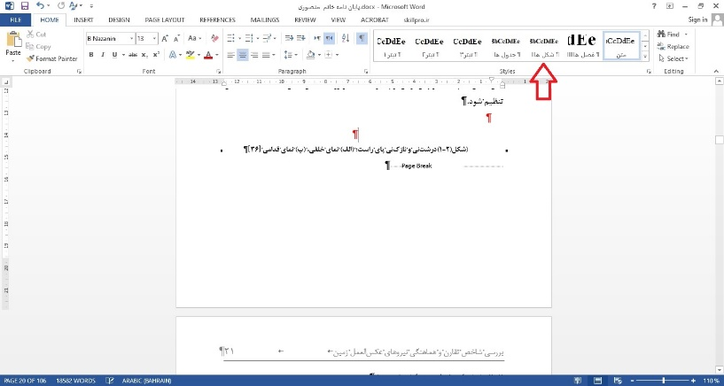

Figure 2.1. Type the figure title here (After typing, click on the “Figure Styles” to format it)

* + - 1. Heading 3 (After typing the title, click on “Title 3” in the “Styles” window)

Type your Persian text in B Nazanin 13 font and your English text in Times new roman 11. Then, in the “Styles” window, click on “Text Styles” to adjust the text.

Type your Persian text in B Nazanin 13 font and your English text in Times new roman 11. Then, in the “Styles” window, click on “Text Styles” to adjust the text.

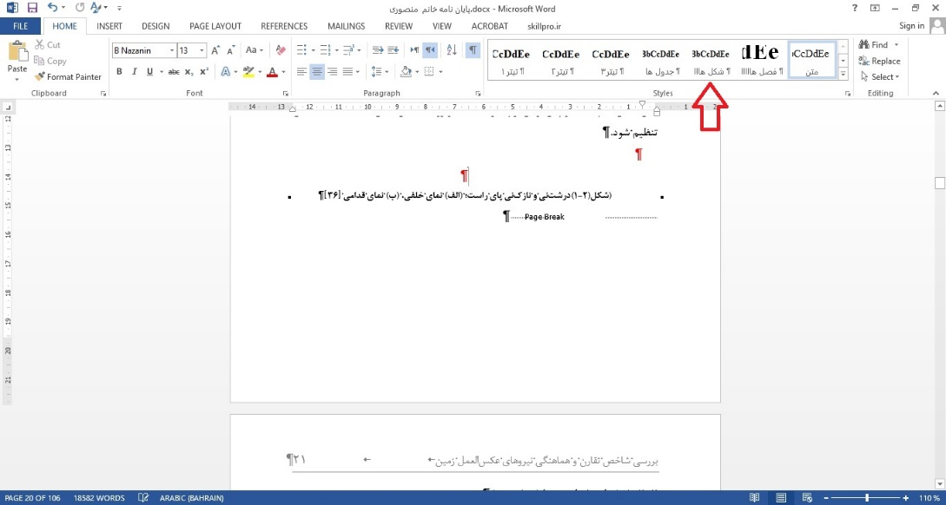

Figure 2.2. Type the figure title here (After typing, click on the “Figure Styles” to format it)

* + - 1. Heading 3 (After typing the title, click on “Title 3” in the “Styles” window)

Type your Persian text in B Nazanin 13 font and your English text in Times new roman 11. Then, in the “Styles” window, click on “Text Styles” to adjust the text.

Type your Persian text in B Nazanin 13 font and your English text in Times new roman 11. Then, in the “Styles” window, click on “Text Styles” to adjust the text.

Table 2.1. Type the table title here (After typing, click on the “Table Styles” to format it)

|  |  |  |  |
| --- | --- | --- | --- |
| Title | Title | Title | Title |
| Type in Times new roman 9 | Type in Times new roman 9 | Type in Times new roman 9 | Type in Times new roman 9 |
| Type in Times new roman 9 | Type in Times new roman 9 | Type in Times new roman 9 | Type in Times new roman 9 |
| Type in Times new roman 9 | Type in Times new roman 9 | Type in Times new roman 9 | Type in Times new roman 9 |
| Type in Times new roman 9 | Type in Times new roman 9 | Type in Times new roman 9 | Type in Times new roman 9 |

* + - 1. Heading 3 (After typing the title, click on “Title 3” in the “Styles” window)

Type your Persian text in B Nazanin 13 font and your English text in Times new roman 11. Then, in the “Styles” window, click on “Text Styles” to adjust the text.

Type your Persian text in B Nazanin 13 font and your English text in Times new roman 11. Then, in the “Styles” window, click on “Text Styles” to adjust the text.

Table 2.2. Type the table title here (After typing, click on the “Table Styles” to format it)

|  |  |  |  |
| --- | --- | --- | --- |
| Title | Title | Title | Title |
| Type in Times new roman 9 | Type in Times new roman 9 | Type in Times new roman 9 | Type in Times new roman 9 |
| Type in Times new roman 9 | Type in Times new roman 9 | Type in Times new roman 9 | Type in Times new roman 9 |
| Type in Times new roman 9 | Type in Times new roman 9 | Type in Times new roman 9 | Type in Times new roman 9 |
| Type in Times new roman 9 | Type in Times new roman 9 | Type in Times new roman 9 | Type in Times new roman 9 |

Formula (2.1) (Type the formula here)

Formula (2.2) (Type the formula here)

Formula (2.3) (Type the formula here)

Note: Detailed descriptions of fonts, font sizes, and writing styles are provided in the guideline.

Chapter 3:   
[Type the chapter title here]

(After typing the title, click on the “Chapters” in the “Styles” window.

3.1. Heading 1 (After typing the title, click on “Title 1” in the “Styles” window)

Type your Persian text in B Nazanin 13 font and your English text in Times new roman 11. Then, in the “Styles” window, click on “Text Styles” to adjust the text.

Type your Persian text in B Nazanin 13 font and your English text in Times new roman 11. Then, in the “Styles” window, click on “Text Styles” to adjust the text.

* + 1. Heading 2 (After typing the title, click on “Title 2” in the “Styles” window)

Type your Persian text in B Nazanin 13 font and your English text in Times new roman 11. Then, in the “Styles” window, click on “Text Styles” to adjust the text.

Type your Persian text in B Nazanin 13 font and your English text in Times new roman 11. Then, in the “Styles” window, click on “Text Styles” to adjust the text.

Figure 3.1. Type the figure title here (After typing, click on the “Figure Styles” to format it)

Formula (3.1) (Type the formula here)

Formula (3.2) (Type the formula here)

Formula (3.3) (Type the formula here)

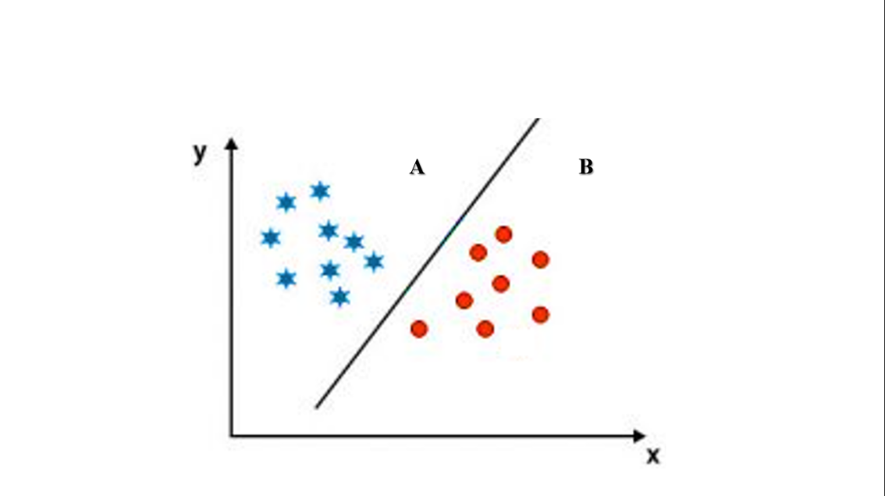

Chart 3.1. Type the chart title here (After typing, click on the “Chart Styles” to format it)

Note: Detailed descriptions of fonts, font sizes, and writing styles are provided in the guideline.

Chapter 4:   
[Type the chapter title here]

(After typing the title, click on the “Chapters” in the “Styles” window.

4.1. Heading 1 (After typing the title, click on “Title 1” in the “Styles” window)

Type your Persian text in B Nazanin 13 font and your English text in Times new roman 11. Then, in the “Styles” window, click on “Text Styles” to adjust the text.

Type your Persian text in B Nazanin 13 font and your English text in Times new roman 11. Then, in the “Styles” window, click on “Text Styles” to adjust the text.

Type your Persian text in B Nazanin 13 font and your English text in Times new roman 11. Then, in the “Styles” window, click on “Text Styles” to adjust the text.

Formula (4.1) (Type the formula here)

Formula (4.2) (Type the formula here)

Formula (4.3) (Type the formula here)

Table 4.1. Type the table title here (After typing, click on the “Table Styles” to format it)

|  |  |  |  |
| --- | --- | --- | --- |
| Title | Title | Title | Title |
| Type in Times new roman 9 | Type in Times new roman 9 | Type in Times new roman 9 | Type in Times new roman 9 |
| Type in Times new roman 9 | Type in Times new roman 9 | Type in Times new roman 9 | Type in Times new roman 9 |
| Type in Times new roman 9 | Type in Times new roman 9 | Type in Times new roman 9 | Type in Times new roman 9 |
| Type in Times new roman 9 | Type in Times new roman 9 | Type in Times new roman 9 | Type in Times new roman 9 |

* + 1. Heading 2 (After typing the title, click on “Title 2” in the “Styles” window)

Type your Persian text in B Nazanin 13 font and your English text in Times new roman 11. Then, in the “Styles” window, click on “Text Styles” to adjust the text.

|  |
| --- |
|  |

Chart 4.1. Type the chart title here (After typing, click on the “Chart Styles” to format it)

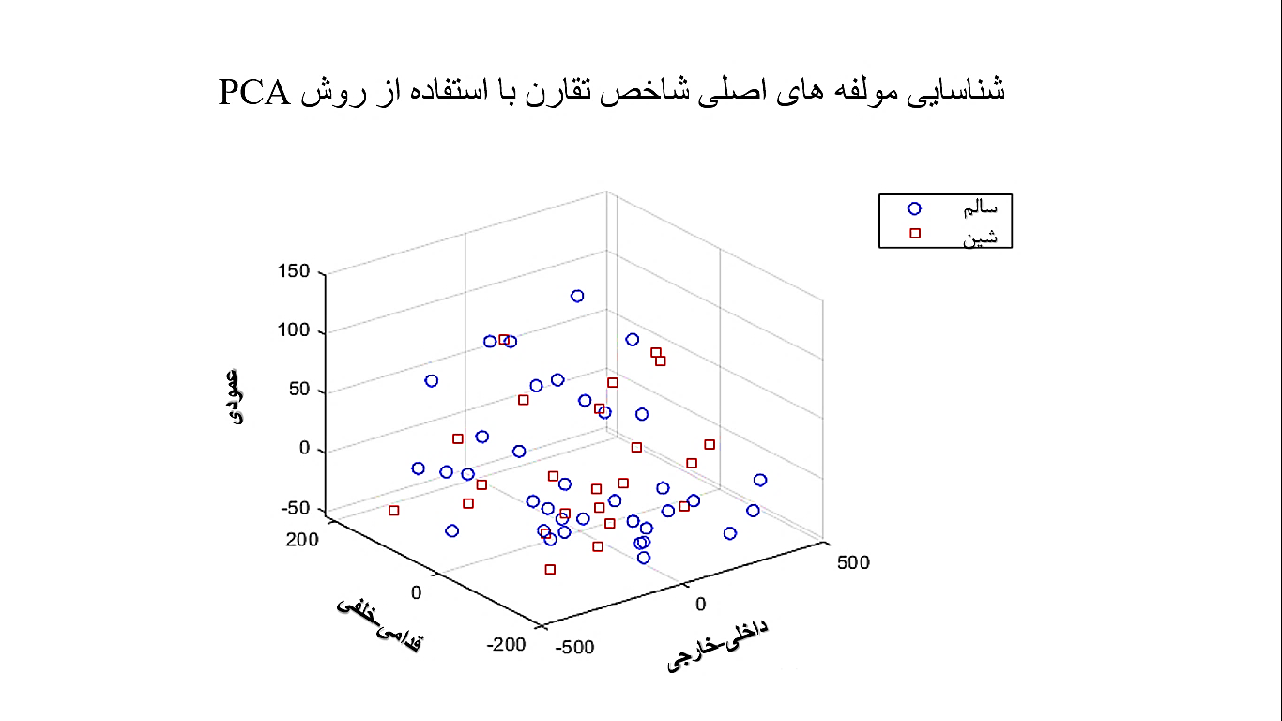

Figure 4.1. Identification of the main components of the symmetry index using PCA method

* + - 1. Heading 3 (After typing the title, click on “Title 3” in the “Styles” window)

Type your Persian text in B Nazanin 13 font and your English text in Times new roman 11. Then, in the “Styles” window, click on “Text Styles” to adjust the text.

Figure 4.2. Identification of the main components of the symmetry index using PCA method

* + - * 1. Heading 4 (After typing the title, click on “Title 4” in the “Styles” window)

Type your Persian text in B Nazanin 13 font and your English text in Times new roman 11. Then, in the “Styles” window, click on “Text Styles” to adjust the text.

Note: Detailed descriptions of fonts, font sizes, and writing styles are provided in the guideline.

Chapter 5:   
[Type the chapter title here]

(After typing the title, click on the “Chapters” in the “Styles” window.

5.1. Heading 1 (After typing the title, click on “Title 1” in the “Styles” window)

Type your Persian text in B Nazanin 13 font and your English text in Times new roman 11. Then, in the “Styles” window, click on “Text Styles” to adjust the text.

Type your Persian text in B Nazanin 13 font and your English text in Times new roman 11. Then, in the “Styles” window, click on “Text Styles” to adjust the text.

Type your Persian text in B Nazanin 13 font and your English text in Times new roman 11. Then, in the “Styles” window, click on “Text Styles” to adjust the text.

Table 5.1. Type the table title here (After typing, click on the “Table Styles” to format it)

|  |  |  |  |
| --- | --- | --- | --- |
| Title | Title | Title | Title |
| Type in Times new roman 9 | Type in Times new roman 9 | Type in Times new roman 9 | Type in Times new roman 9 |
| Type in Times new roman 9 | Type in Times new roman 9 | Type in Times new roman 9 | Type in Times new roman 9 |
| Type in Times new roman 9 | Type in Times new roman 9 | Type in Times new roman 9 | Type in Times new roman 9 |
| Type in Times new roman 9 | Type in Times new roman 9 | Type in Times new roman 9 | Type in Times new roman 9 |

* + 1. Heading 2 (After typing the title, click on “Title 2” in the “Styles” window)

Type your Persian text in B Nazanin 13 font and your English text in Times new roman 11. Then, in the “Styles” window, click on “Text Styles” to adjust the text.

|  |
| --- |
|  |

Chart 5.1. Type the chart title here (After typing, click on the “Chart Styles” to format it)



Figure 5.1. Identification of the main components of the symmetry index using PCA method

5.1.1.1. Heading 3 (After typing the title, click on “Title 3” in the “Styles” window)

Type your Persian text in B Nazanin 13 font and your English text in Times new roman 11. Then, in the “Styles” window, click on “Text Styles” to adjust the text.

Figure 2.2. Identification of the main components of the symmetry index using PCA method

* + - * 1. Heading 4 (After typing the title, click on “Title 4” in the “Styles” window)

Type your Persian text in B Nazanin 13 font and your English text in Times new roman 11. Then, in the “Styles” window, click on “Text Styles” to adjust the text.

Note: Detailed descriptions of fonts, font sizes, and writing styles are provided in the guideline.

**References**

Persian References

-Type Persian references in B Nazanin 13 font and English references in Times new roman 11

-Type Persian references in B Nazanin 13 font and English references in Times new roman 11

-Type Persian references in B Nazanin 13 font and English references in Times new roman 11

-Type Persian references in B Nazanin 13 font and English references in Times new roman 11

English References

-Type Persian references in B Nazanin 13 font and English references in Times new roman 11

-Type Persian references in B Nazanin 13 font and English references in Times new roman 11

-Type Persian references in B Nazanin 13 font and English references in Times new roman 11

-Type Persian references in B Nazanin 13 font and English references in Times new roman 11

Note: Detailed descriptions of fonts, font sizes, and writing styles are provided in the guideline.

Appendices

Type your Persian text in B Nazanin 13 font and your English text in Times new roman 11. Then, in the “Styles” window, click on “Text Styles” to adjust the text.

**Descriptive Words**

Persian-English Words

English-Persian Words

**Reviewers’ Approval/Final Oral Defense Report**

Faculty of ….

Table 1. Student’s information

|  |  |  |  |  |  |
| --- | --- | --- | --- | --- | --- |
| First Name and Last Name | Major | Field | Program type (state funded/tuition-based) | Entrance Year | Student ID |
|  |  |  |  |  |  |
| Email Address: | | | | | |

Table 2. Thesis title and final oral defense date

|  |  |
| --- | --- |
| Thesis Title |  |
| Final Oral Defense Date and Time |  |

Table 3. Evaluation score

|  |  |  |  |  |
| --- | --- | --- | --- | --- |
| Score (in number) | | Score (in word): | | |
| Less than 14 | 14-15.99 | 16-17.99 | 18-18.99 | 19-20 |
| Failed | Acceptable | Good | Very Good | Excellent |

Table 4. Professor’s information

|  |  |  |  |  |  |
| --- | --- | --- | --- | --- | --- |
| First Name and Last Name | Specialty and Research Domain | Academic Rank | Position in Thesis | Affiliation | Date and Signature |
|  |  |  |  |  |  |
|  |  |  |  |  |  |
|  |  |  |  |  |  |
|  |  |  |  |  |  |
|  |  |  |  |  |  |
|  |  |  |  |  |  |

Table 5. Postgraduate representative’s information

|  |  |
| --- | --- |
| First Name and Last Name | Date and Signature |
|  |  |

**Abstract:**

Type your English text in Times new roman 11.

**Keywords: 1, 2, 3, 4, 5**

**Compiled and edited by: Office of Research and Technology, University of Mazandaran**

**January 2022**